Azure Security Review Service

Public cloud environments provide much-needed technology innovations to businesses that face the challenges of not being able to innovate at a pace. However, adopting cloud technologies present businesses with a more significant challenge of securing their cloud infrastructure because the security in the cloud is a shared responsibility.

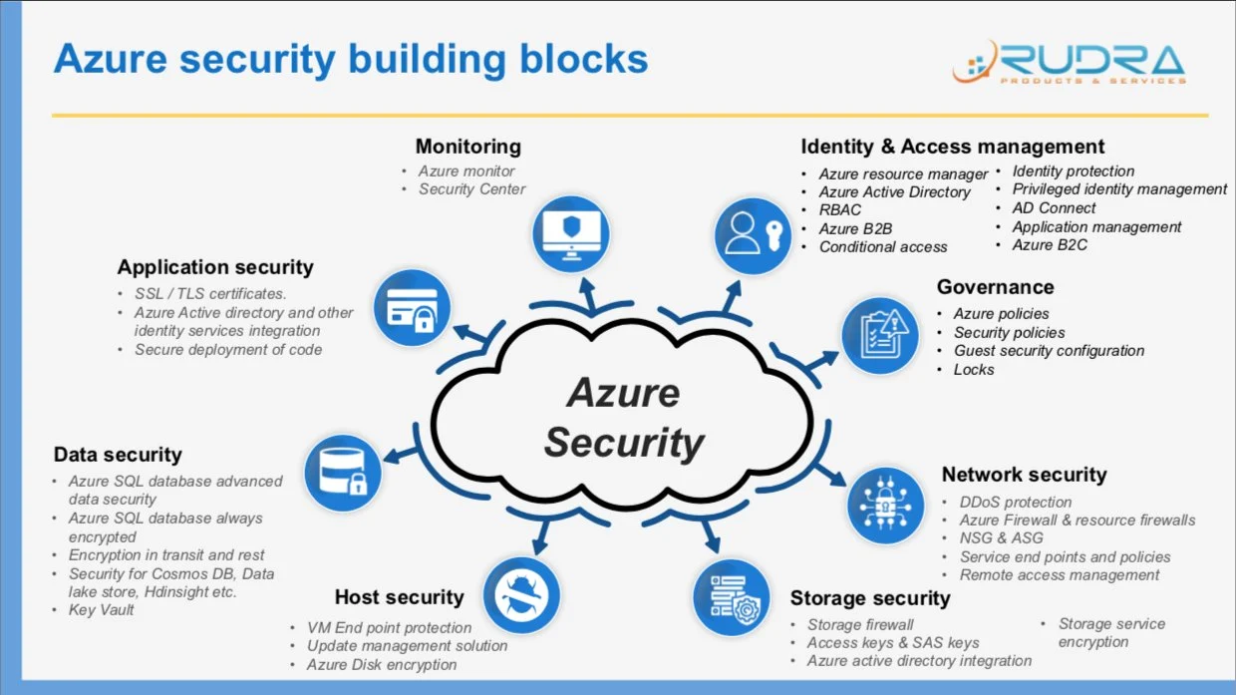

Dozens of companies have reported hacks into their infrastructure, loss of user/company data, millions in revenue loss, and not to mention damage to their reputation.

Rocky Road Solutions LLC provides a superior cloud security review service to safeguard an organization's cloud infrastructure. The deliverable of this service is a detailed report listing all areas of possible vulnerabilities, weaknesses, and misconfigurations in your cloud environment. Along with this report, we will provide immediate fixes for critical security issues in the production environment while ensuring business continuity.

Service Highlights

Below is a summary of activities completed by our cloud security experts to prepare the cloud security review report for your cloud infrastructure:
Azure WAF: We review and set up application static and dynamic security using Azure WAF.
Security of identity and access management (IAM): IAM security is reviewed in the light of industry best practices for accounts, organizations, and users, management of credentials and secrets, and policy enforcement. This review ensures that no employee, application service role, or process can compromise the security of Azure accounts.

Security of the network: All network assets, including VPCs, gateways, and routing configurations, are reviewed to ensure isolation, protection, and intrusion detection controls are in place. Public ingress/egress endpoints are evaluated for security, compliance, and regional/global availability.
Data and Communication Security: Review all cloud storage technologies, including Blob, Table, Queue Storage and File Storage for required encryption, versioning, and backup. Review data security in transit to ensure appropriate TLS protocols are being used. Review of security controls set up to ensure only correctly assigned owners have access to storage.
Security of Virtual Machines and App Services: We will review Virtual Machines and App services and make sure that best practices are followed regarding integrated security. We will check existing periodic, and on-demand vulnerability scanning controls and IAM/Kubernetes service accounts so only authorized users and applications can provision or use compute resources.

Continuous Security Setup

Rocky Road Solutions engineers will set up continuous capture and logging of all traffic flows in and out of VPC and storage of Azure API audit trials so intrusion detection and unauthorized access /usage of services can immediately be prevented. We will set up Configuration monitoring controls based on customer security requirements, including:
- Operational-Best-Practices-for-Azure well-architected framework
- Operational-Best-Practices-for-CIS-Critical-Security-Controls

- Any additional security control, including PCI_DSS, NIST, SOC, HIPAA, and GDPR

We will also set up Azure security hub reporting for all controls so a 360-degree view of security is available all the time and can be set up.
- Azure Firewall for advanced intrusion detection

- Azure Key-vaults for data security.

- Web application firewalls for public endpoint security

Rocky Road Solutions Advantage

Our commitment to our clients is that we will do everything possible to ensure your Azure subscriptions are secure.

For Additional Information

For any additional inquiries please send email at contact@rockyroadsolutions.com and out team will contact you within 1 to 2 business days.

